Chapter 5, Solution 49.

R₁ = R₃ = 20kΩ, R₂/(R₁) = 4

i.e. R₂ = 4R₁ = 80kΩ = R₄

Verify: 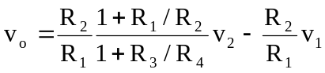

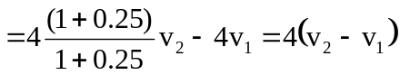

Thus, R₁ = R₃ = 20 kΩ, R₂ = R₄ = 80 kΩ.

